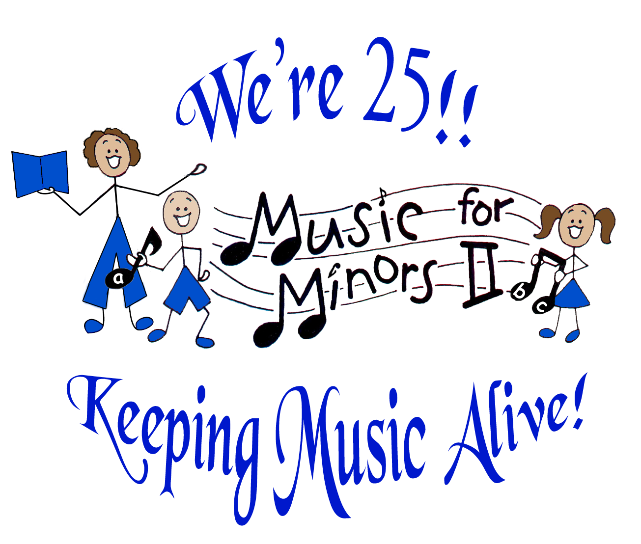
MUSIC FOR MINORS II

Serving the community since 1988

Board of Directors

President
Virginia Williamson

Board Members
Jessica Chang Kapushinski
Susan Lesh
Rachel Bello
Veera Kazak
Christina Melnarik
Lelia Ng
Ed Mateo

Executive Director
Carol Zilli

Admin. Asst. / Liaison Coordinator
Sharon Filippi

Program Coordinator
Susan Lesh

Docent Manager/ Training Coordinator
Sandy Shimkus

Docent Training Coordinator - CV
Rose Godfrey

▪▪▪

Advisory Council

Ted Bresler,
Alameda County Arts Commission

Steve Cho,
Fremont Symphony

Charlotte Diamond,
Recording Artist

Jerry Green,
Retired Director,
CV Adult School

Peggy Herndon,
CFO - Floor Seal Technology

Leo Hinkel,
Retired Principal

Brian Hughes,
Fremont Bank

Terry Liebowitz,
Castro Valley Arts Foundation

Lily Mei,
FUSD Board

Ray Rodriguez,
NUSD Board

Margaret Thornberry,
Fremont Cultural Arts Council

37141 Second Street, Fremont, CA 94536
510-733-1189 phone/510-713-9879 fax
www.musicforminors2.org
“Nurturing a lifelong love & literacy of music in children’s classrooms and lives”

December 2012

Dear Friend of the Arts,

Children need music for healthy mental, emotional, and physical development, yet severe budgetary cutbacks in arts education are widespread in our schools. Despite the fact that
research verifies how music integrates the brain, improves students’ cognitive skills, and enhances academic success and self-confidence, we still find a serious void of music in school curriculum.

Music for Minors II (MFMII), the 501 c(3)nonprofit music enrichment organization
(EIN #94-310-2307), has helped to fill this void since 1988 by nurturing the love and literacy
of music for almost 5,000 children in pre-school through sixth grade classrooms and on professional stages.

For thousands of children, MFMII may be their only exposure to the healing and magical power of music. Thanks to our trained community volunteers, children receive thirty
minute weekly music lessons in singing/signing songs, rhythmic movement/dance, and simple instrumentation. The classroom teacher is also empowered by our engaging MFMII activities that spark creativity, critical thinking, and imagination.

On March 15, 2013, Music for Minors II is “Celebrating 25 Years of Music, Magic, and Memories.” This Gala Benefit Event will be held at the Marriott Fremont from 6:30 –11:00 pm to commemorate our 25 years of service to the community. We hope you will be able to attend this exciting event featuring great food, musical artistry and entertainment, including a performance by children who receive MFMII lessons in our schools.

Proceeds from this event will enable MFMII to expand our services in the San Francisco East Bay area so that many more children in need will be enriched with music. Please partner with us in our mission for greater expansion of our services by selecting your choice of support on the enclosed sponsor card.

It doesn’t take much to make the musical difference in a child’s life. Becoming a Friend of MFMII for $100 can sponsor a community volunteer to take the annual fall training class, and as a Patron for only $200, you may sponsor a classroom of children with music for one school year. Our Silver, Gold and Platinum sponsors will directly impact our MFMII Scholarship Fund and program expansion! We will recognize your generosity at our Gala event, in our newsletters and on our website.

We invite you to join us by becoming a Co-Sponsor of our Gala event. Please mail the enclosed sponsor card with your check to Music for Minors II at the address above. You will receive a tax deductible receipt for your donation.

Thank you so much for your consideration of this request. Your gift from the heart will change the life of a child forever.

Sincerely,

Carol Zilli
Executive Director/Founder

